EXPERIMENT-8
NAME: Yuvaraj A ROLL NO:240701809
Create storyboards to represent the user flow for your application using Balsamiq

Aim
To design and prototype a user-friendly wireframe for QuickBite Food Ordering App using Balsamiq, representing the complete user workflow in a single combined view.
Tools Used
Balsamiq (Wireframing Tool)

Description
This project presents a QuickBite Food Ordering Application interface designed using Balsamiq. The main objective of this experiment is to represent the complete user flow of the application through a storyboard in a single combined wireframe.
Instead of designing separate screens individually, all important stages of the application are arranged together in one view to clearly explain how a user interacts with the system from start to finish. This method helps in understanding navigation flow, user actions, and screen transitions easily.
The wireframe includes the Welcome Screen, where users can sign up or log in, followed by the Home Screen, where users can browse food categories and search for items. It also contains the Item Details Screen, where users can view product information and add items to the cart.
Further, the storyboard includes the Cart Screen, where selected items and total price are displayed, followed by the Payment Screen, where users can choose their preferred payment method such as UPI, Card, or Cash on Delivery. Finally, the Order Confirmation Screen displays successful order placement.
This combined storyboard gives a complete overview of the QuickBite food ordering process and helps in designing a user-friendly and efficient mobile application.

Wireframe
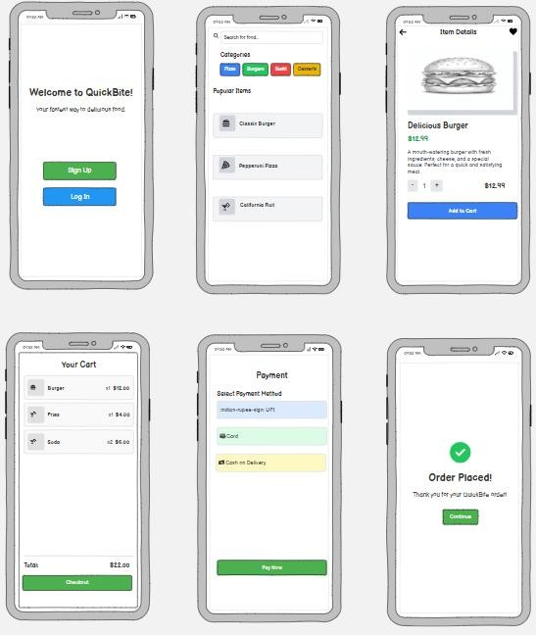

Explanation of the Wireframe
The combined wireframe represents the full workflow of the QuickBite food ordering application:

Welcome Screen
- Users can access the application through Sign Up or Log In options.
- It acts as the starting page of the app.

Home Screen
- Users can search for food items using the search bar.
- Categories such as Burger, Pizza, Drinks, and Dessert are displayed.
- Food items are listed with quick selection options.

Item Details Screen
- Displays food item image, name, and price.
- Shows short description of the selected item.
- Users can add the item to cart.

Cart Screen
- Displays selected food items and total amount.
- Users can review the cart before checkout.
- Checkout option is provided.

Payment Screen
- Provides payment options such as UPI, Card, and Cash on Delivery.
- Users can complete payment securely.

Order Confirmation Screen
- Displays successful order confirmation message.
- Gives a clear end point of the ordering process.

Conclusion
The combined wireframe effectively represents the entire food ordering process in a single view. It helps in understanding the flow of the application and user interactions across different stages, making it easier to design and develop a user-friendly food ordering system.

Wireframe Link : https://balsamiq.cloud/spi8p2g/pjzgwym/rA310

